A Secure and Dynamic Multi-keyword Ranked Search Scheme over Encrypted Cloud Data
ABSTRACT
A Secure and Dynamic Multi-keyword Ranked Search Scheme over Encrypted Cloud Data Due to the increasing popularity of cloud computing, more and more data owners are motivated to outsource their data to cloud servers for great convenience and reduced cost in data management. However, sensitive data should be encrypted before outsourcing for privacy requirements, which obsoletes data utilization like keyword-based document retrieval. In this paper, we present a secure multi-keyword ranked search scheme over encrypted cloud data, which simultaneously supports dynamic update operations like deletion and insertion of documents. Specifically, the vector space model and the widely-used TFIDF model are combined in the index construction and query generation. We construct a special tree-based index structure and propose a “Greedy Depth-first Search” algorithm to provide efficient multi-keyword ranked search. The secure kNN algorithm is utilized to encrypt the index and query vectors, and meanwhile ensure accurate relevance score calculation between encrypted index and query vectors. In order to resist statistical attacks, phantom terms are added to the index vector for blinding search results . Due to the use of our special tree-based index structure, the proposed scheme can achieve sub-linear search time and deal with the deletion and insertion of documents flexibly. Extensive experiments are conducted to demonstrate the efficiency of the proposed scheme.
EXISTING SYSTEM
The existing techniques on keyword-based information retrieval, which are widely used on the plaintext data, cannot be directly applied on the encrypted data. Downloading all the data from the cloud and decrypt locally is obviously impractical. All these multi keyword search schemes retrieve search results based on the existence of keywords, which cannot provide acceptable result ranking functionality. However, sensitive data should be encrypted before outsourcing for privacy requirements, which obsoletes data utilization like keyword-based document retrieval.
EXISTING SYSTEM ALGORITHMS
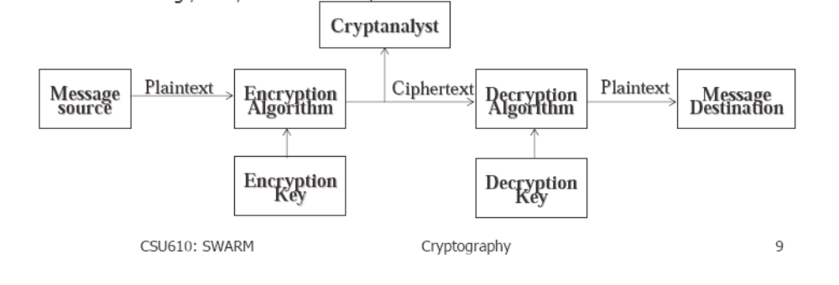

Specifically, the vector space model and the widely-used TFIDF model are combined in the index construction and query generation.
PROPOSED SYSTEM
A Secure and Dynamic Multi-keyword Ranked Search Scheme over Encrypted Cloud Data We construct a special tree-based index structure and propose a “Greedy Depth-first Search” algorithm to provide efficient multi-keyword ranked search. The proposed scheme can achieve sub-linear search time and deal with the deletion and insertion of documents flexibly. Extensive experiments are conducted to demonstrate the efficiency of the proposed scheme.
- Abundant works have been proposed under different threat models to achieve various search functionality,
- Recently, some dynamic schemes have been proposed to support inserting and deleting operations on document collection.
- This paper proposes a secure tree-based search scheme over the encrypted cloud data, which supports multi keyword ranked search and dynamic operation on the document collection.

PROPOSED SYSTEM ALGORITHMS
- Algorithm to provide efficient multi-keyword ranked search .
- The secure kNN algorithm is utilized to encrypt the index and query vectors.
- Propose a “Greedy Depth-first Search” algorithm based on this index tree.
- Algorithm achieves better-than-linear search efficiency but results in precision loss.
- The LSH algorithm is suitable for similar search but cannot provide exact ranking.
- {I′s ; ci} ← GenUpdateInfo (SK; Ts; i; up type)) This algorithm generates the update information {I′s ; ci} which will be sent to the cloud server.

ADVANTAGES
Despite of the various advantages of cloud services, outsourcing sensitive information such as e-mails, personal health records, company finance data, government documents, etc.

System Architecture
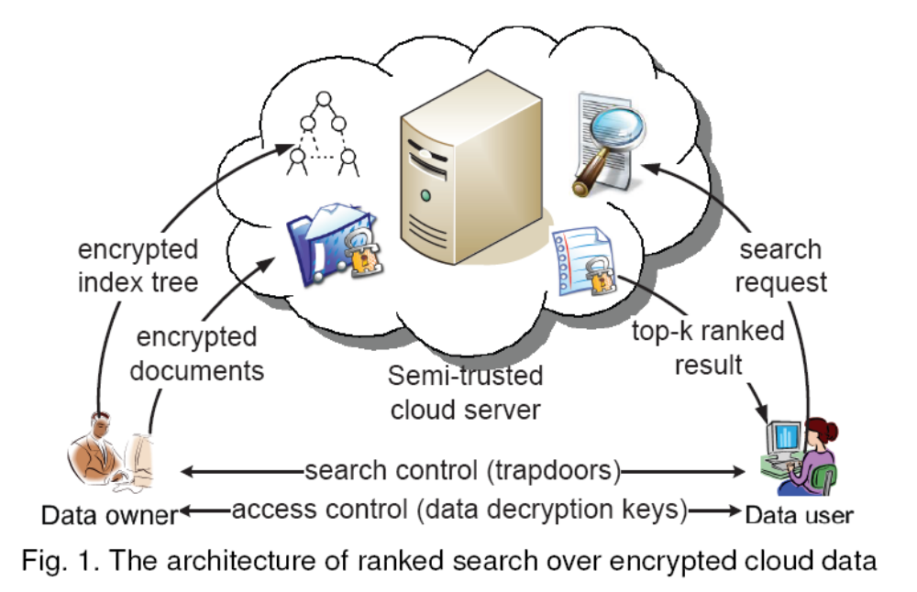

TREE-BASED INDEX WITH THE DOCUMENT COLLECTION

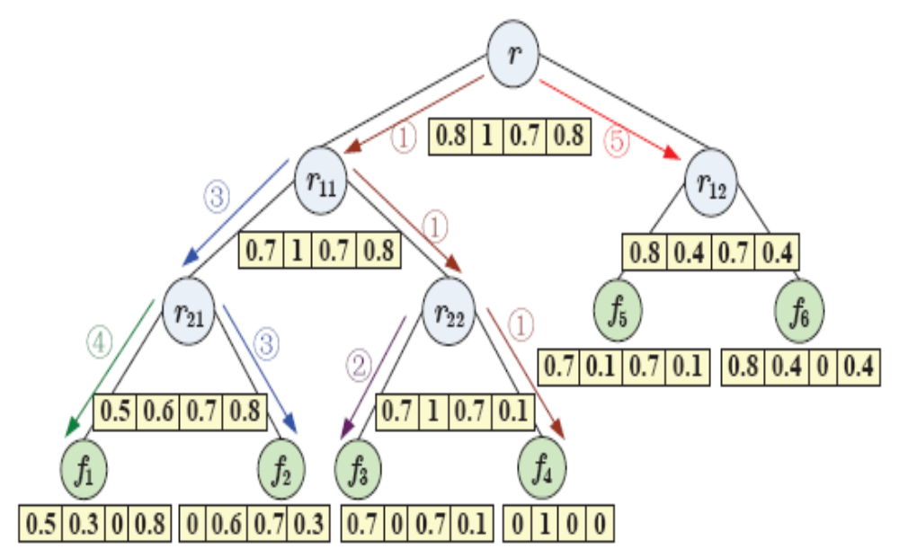

We construct a special keyword balanced binary tree as the index, and propose a “Greedy Depth-first Search” algorithm to obtain better efficiency than linear search.
SYSTEM CONFIGURATION:
HARDWARE REQUIREMENTS:
Hardware - Pentium
Speed - 1.1 GHz
RAM - 1GB
Hard Disk - 20 GB
Key Board - Standard Windows Keyboard
Mouse - Two or Three Button Mouse
Monitor - SVGA

SOFTWARE REQUIREMENTS:

Operating System : Windows Family
Technology : Java and J2EE
Web Technologies : Html, JavaScript, CSS
Web Server : Tomcat
Database : My SQL
Java Version : J2SDK1.7 & Above

